Active Directory Domain Documentation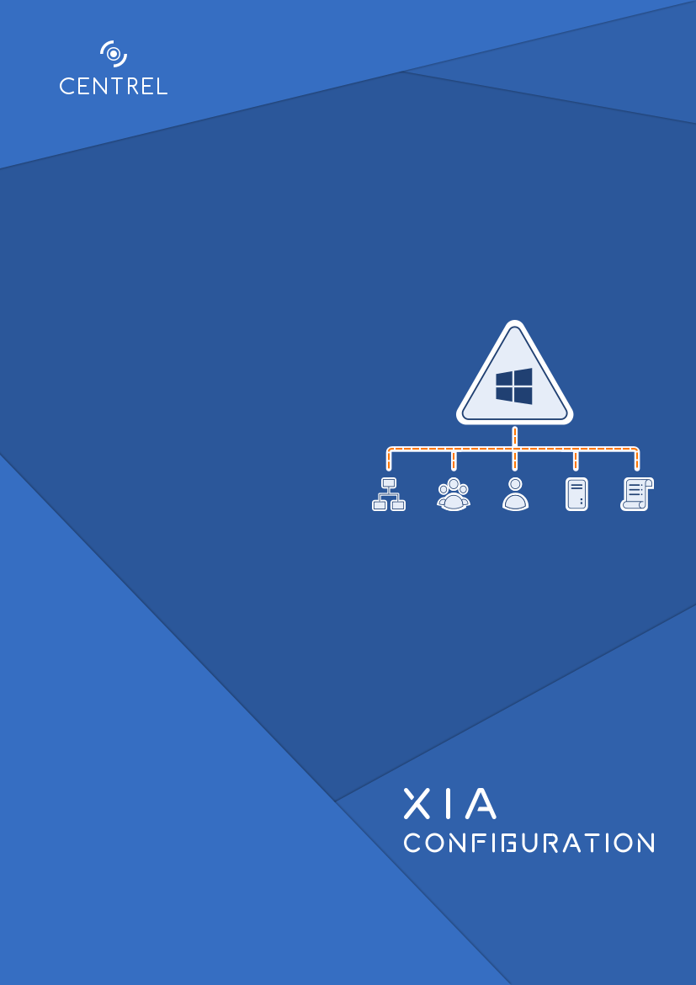

europe.contoso.com

Company Confidential

|  |  |
| --- | --- |
| Document Properties | |
| Author | CONTOSO\sysadmin |
| Product | XIA Configuration Server [0.0.0.0] |
| Date | 09 September 2025 09:24:40 |
| Version | 1.04 |



Table of Contents

General Information 3

Relationships 4

Relationship Map 5

Domain 6

Computers 7

DC-EU-2K22 8

Domain Controllers 10

DC-EU-2K22 11

Fine-Grained Password Policies 14

Example Password Policy 15

Foreign Security Principals 17

S-1-5-11 18

Groups 19

Domain Admins 20

Domain Users 21

Managed Service Accounts 22

xiaservice 23

Operations Masters 24

Recycle Bin 25

Trusts 26

contoso.com 27

northwind.com 28

uk.europe.contoso.com 29

Users 30

Administrator 31

Guest 33

Group Policy 35

Group Policy Objects 36

Contoso Basic Group Policy Object 37

Computer Configuration 39

Administrative Templates 40

User Configuration 42

Starter Group Policy Objects 43

Replication 44

Inter-Site Transports 45

IP 46

SMTP 47

Sites 48

Contoso-Europe 49

Servers 52

DC-EU-2K22 53

Automatically Generated 54

Subnets 56

Schema 57

Schema Classes 58

account 59

addressTemplate 60

Schema Attributes 61

associatedDomain 62

associatedName 63

Version History 64

# General Information

Provides general information for this item.

|  |  |  |  |
| --- | --- | --- | --- |
| |  |  | | --- | --- | |  | General Information | | |
| Name | europe.contoso.com |
| Description | An example child domain. |
| Primary Owner Name | Technical Support |
| Primary Owner Contact | support@contoso.com |

|  |  |  |  |
| --- | --- | --- | --- |
| |  |  | | --- | --- | |  | System Information | | |
| Item Path | Contoso |
| Identifier | b8a1a01a-c257-44d4-b909-9694d470ac8d |
| Item ID | 1046 |
| Version ID | 1.04 |
| Check Out Status | Available |

|  |  |  |
| --- | --- | --- |
| |  |  | | --- | --- | |  | Custom Item Details | |

This is a demonstration Active Directory domain.

## Relationships

Provides a summary of the relationships between this item and other items in the environment.

|  |  |  |  |  |  |  |
| --- | --- | --- | --- | --- | --- | --- |
| |  |  | | --- | --- | |  | 6 Relationships | | | | | |
| Item ID | Direction | Name | Type | Relationship Type |
| |  |  | | --- | --- | |  | 1045 | | Outbound | DC-EU-2K22 | Windows Server | Hosted On |
| |  |  | | --- | --- | |  | 1000 | | Outbound | Contoso | Container | Contained Within |
| |  |  | | --- | --- | |  | 1004 | | Outbound | contoso.com | Active Directory Domain | Domain Trust Relationship |
| |  |  | | --- | --- | |  | 1004 | | Outbound | contoso.com | Active Directory Domain | Domain Trust Relationship |
| |  |  | | --- | --- | |  | 1043 | | Outbound | northwind.com | Active Directory Domain | Domain Trust Relationship |
| |  |  | | --- | --- | |  | 1044 | | Outbound | uk.europe.contoso.com | Active Directory Domain | Domain Trust Relationship |

## Relationship Map

This section provides a visualization of the relationships between this item and other items in the system.

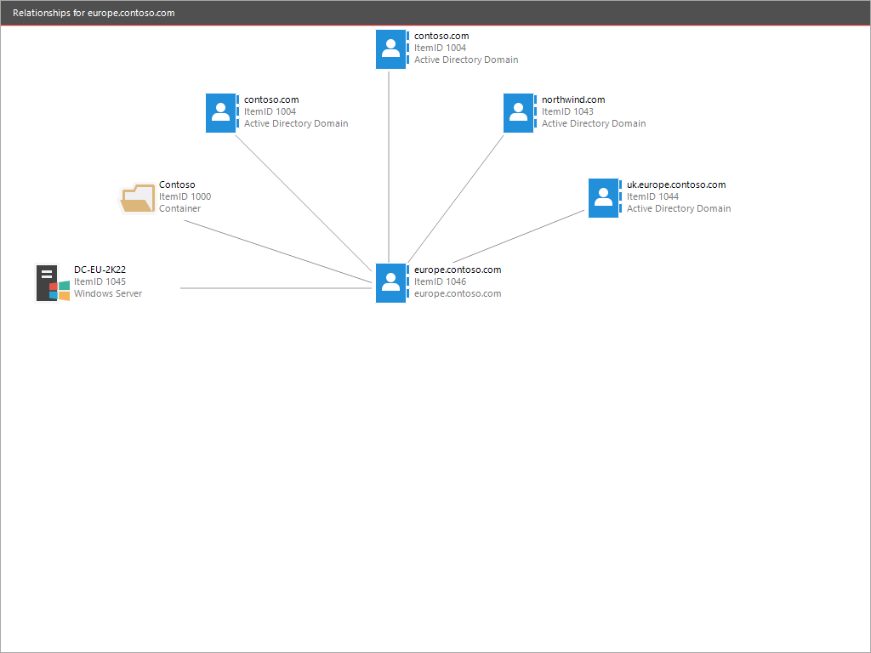

# Domain

Active Directory Domain Services (AD DS), provides the methods for storing directory data and making this data available to network users and administrators.

|  |  |  |  |
| --- | --- | --- | --- |
| |  |  | | --- | --- | |  | General | | |
| Description | An example child domain. |
| Child Domain Names | uk.europe.contoso.com |
| Domain Functional Level | Windows Server 2016 |
| Last Logon Replication Interval | System Default |

|  |  |  |  |
| --- | --- | --- | --- |
| |  |  | | --- | --- | |  | Identifiers | | |
| Domain Name | europe.contoso.com |
| Distinguished Name | DC=europe,DC=contoso,DC=com |
| NetBIOS Name | EUROPE |
| Parent Domain Name | contoso.com |
| Security Identifier | S-1-5-21-4140458633-4188990453-1364030867 |

|  |  |  |  |
| --- | --- | --- | --- |
| |  |  | | --- | --- | |  | Forest | | |
| Forest Name | contoso.com |
| Forest Functional Level | Windows Server 2016 |

|  |  |  |  |
| --- | --- | --- | --- |
| |  |  | | --- | --- | |  | Well-Known Containers | | |
| Computers Container | CN=Computers,DC=europe,DC=contoso,DC=com |
| Deleted Objects Container | CN=Deleted Objects,DC=europe,DC=contoso,DC=com |
| Domain Controllers Container | OU=Domain Controllers,DC=europe,DC=contoso,DC=com |
| Foreign Security Principals Container | CN=ForeignSecurityPrincipals,DC=europe,DC=contoso,DC=com |
| Lost And Found Container | CN=LostAndFound,DC=europe,DC=contoso,DC=com |
| Quotas Container | CN=NTDS Quotas,DC=europe,DC=contoso,DC=com |
| System Container | CN=System,DC=europe,DC=contoso,DC=com |
| Users Container | CN=Users,DC=europe,DC=contoso,DC=com |

## Computers

Computer accounts are similar to user accounts however are used to allow computers to participate in the domain.

|  |  |  |  |  |  |
| --- | --- | --- | --- | --- | --- |
| |  |  | | --- | --- | |  | 1 Computers | | | | |
| Name | Operating System | Domain Controller | Description |
| |  |  | | --- | --- | |  | DC-EU-2K22 | | Windows Server 2022 Datacenter | True | Regional domain controller for europe. |

### DC-EU-2K22

Computer accounts are similar to user accounts however are used to allow computers to participate in the domain.

|  |  |  |  |
| --- | --- | --- | --- |
| |  |  | | --- | --- | |  | General | | |
| Description | Regional domain controller for europe. |
| Host Name | DC-EU-2K22.europe.contoso.com |
| SAM Account Name | DC-EU-2K22 |
| Account Locked Out | False |
| Domain Controller | True |
| Enabled | True |
| Last Logon | 18 August 2023 17:00:11 |
| Security Identifier | S-1-5-21-4140458633-4188990453-1364030867-1000 |

|  |  |  |  |
| --- | --- | --- | --- |
| |  |  | | --- | --- | |  | Location | | |
| Location | Europe |

|  |  |  |  |
| --- | --- | --- | --- |
| |  |  | | --- | --- | |  | Operating System | | |
| Operating System Name | Windows Server 2022 Datacenter |
| Operating System Version | 10.0 (20348) |
| Operating System Service Pack |  |

|  |  |  |  |  |
| --- | --- | --- | --- | --- |
| |  |  | | --- | --- | |  | 1 Memberships | | | |
| Account Name | Canonical Name | Type |
| |  |  | | --- | --- | |  | EUROPE\Domain Controllers | | europe.contoso.com/Users/Domain Controllers | Group |

|  |  |  |  |  |
| --- | --- | --- | --- | --- |
| |  |  | | --- | --- | |  | Managed By | | | |
| Account Name | Canonical Name | Type |
| |  |  | | --- | --- | |  | EUROPE\sysadmin | | europe.contoso.com/Users/sysadmin | User |

|  |  |  |  |
| --- | --- | --- | --- |
| |  |  | | --- | --- | |  | Directory Object | | |
| Date Created | 18 August 2023 16:59:31 |
| Date Last Modified | 25 August 2023 11:55:45 |
| Canonical Name | europe.contoso.com/Domain Controllers/DC-EU-2K22 |
| Distinguished Name | CN=DC-EU-2K22,OU=Domain Controllers,DC=europe,DC=contoso,DC=com |
| Identifier | c368871e-7c32-41b1-9889-308d8bf3dc13 |
| Protected From Accidental Deletion | False |

## Domain Controllers

A domain controller is a server that participates in hosting the Active Directory service.

Read-Only domain controllers (RODCs) provide a read-only copy of the directory to service branch office users.

|  |  |  |  |  |  |
| --- | --- | --- | --- | --- | --- |
| |  |  | | --- | --- | |  | 1 Domain Controllers | | | | |
| Name | Read-Only | Global Catalog | Description |
| |  |  | | --- | --- | |  | DC-EU-2K22 | | False | True | Regional domain controller for europe. |

### DC-EU-2K22

A domain controller is a server that participates in hosting the Active Directory service.

Read-Only domain controllers (RODCs) provide a read-only copy of the directory to service branch office users.

|  |  |  |  |
| --- | --- | --- | --- |
| |  |  | | --- | --- | |  | General | | |
| Host Name | DC-EU-2K22.europe.contoso.com |
| Description | Regional domain controller for europe. |
| Location | Europe |
| Bridgehead Server Transports |  |
| Managed By | EUROPE\sysadmin |
| Global Catalog | True |
| Read Only | False |
| Query Policy | Default Query Policy |
| Security Identifier | S-1-5-21-4140458633-4188990453-1364030867-1000 |
| Site | Contoso-Europe |

|  |  |  |  |
| --- | --- | --- | --- |
| |  |  | | --- | --- | |  | Partitions | | |
| Default Partition | DC=europe,DC=contoso,DC=com |
| Partitions | DC=europe,DC=contoso,DC=com  CN=Schema,CN=Configuration,DC=contoso,DC=com  CN=Configuration,DC=contoso,DC=com  DC=uk,DC=europe,DC=contoso,DC=com  DC=contoso,DC=com |

|  |  |  |  |  |
| --- | --- | --- | --- | --- |
| |  |  | | --- | --- | |  | 1 Memberships | | | |
| Account Name | Canonical Name | Type |
| |  |  | | --- | --- | |  | EUROPE\Domain Controllers | | europe.contoso.com/Users/Domain Controllers | Group |

|  |  |  |  |
| --- | --- | --- | --- |
| |  |  | | --- | --- | |  | Operating System (Directory) | | |
| Operating System Name | Windows Server 2022 Datacenter |
| Operating System Service Pack |  |
| Operating System Version | 10.0 (20348) |

|  |  |  |  |
| --- | --- | --- | --- |
| |  |  | | --- | --- | |  | Networking Settings | | |
| IPv4 Addresses | 192.168.131.245 |
| IPv6 Addresses |  |
| LDAP Port | 389 |
| SSL Port | 636 |

|  |  |  |  |
| --- | --- | --- | --- |
| |  |  | | --- | --- | |  | Service Principal Names | | |
| Service Principal Names | Dfsr-12F9A27C-BF97-4787-9364-D31B6C55EB04/DC-EU-2K22.europe.contoso.com  GC/DC-EU-2K22.europe.contoso.com/contoso.com  RestrictedKrbHost/DC-EU-2K22.europe.contoso.com  RestrictedKrbHost/DC-EU-2K22  RPC/e01d000c-764d-4ef3-833b-e5a6e8f70c3f._msdcs.contoso.com  HOST/DC-EU-2K22/EUROPE  HOST/DC-EU-2K22.europe.contoso.com/EUROPE  HOST/DC-EU-2K22  HOST/DC-EU-2K22.europe.contoso.com  HOST/DC-EU-2K22.europe.contoso.com/europe.contoso.com  E3514235-4B06-11D1-AB04-00C04FC2DCD2/e01d000c-764d-4ef3-833b-e5a6e8f70c3f/europe.contoso.com  ldap/DC-EU-2K22/EUROPE  ldap/e01d000c-764d-4ef3-833b-e5a6e8f70c3f._msdcs.contoso.com  ldap/DC-EU-2K22.europe.contoso.com/EUROPE  ldap/DC-EU-2K22  ldap/DC-EU-2K22.europe.contoso.com  ldap/DC-EU-2K22.europe.contoso.com/europe.contoso.com |

|  |  |  |  |
| --- | --- | --- | --- |
| |  |  | | --- | --- | |  | Host Information | | |
| Computer Fully Qualified Domain Name | DC-EU-2K22.europe.contoso.com |
| Manufacturer | VMware, Inc. |
| Model | VMware7,1 |
| Operating System Name | Microsoft Windows Server 2022 Datacenter |
| Processors | Intel(R) Core(TM) i9-10885H CPU @ 2.40GHz |
| Serial Number | VMware-56 4d 42 ab 83 44 6c fe-14 41 f9 07 55 37 f5 7d |
| Service Pack | [None Installed] |

|  |  |  |  |
| --- | --- | --- | --- |
| |  |  | | --- | --- | |  | Directory Service Paths | | |
| Database Path | C:\Windows\NTDS |
| Log Files Path | C:\Windows\NTDS |
| SYSVOL Path | C:\Windows\SYSVOL\sysvol |

|  |  |  |  |
| --- | --- | --- | --- |
| |  |  | | --- | --- | |  | Operations Master Roles | | |
| Domain Naming Master | False |
| Infrastructure Master | True |
| PDC Emulator | True |
| RID Master | True |
| Schema Master | False |

|  |  |  |  |
| --- | --- | --- | --- |
| |  |  | | --- | --- | |  | Directory Object | | |
| Date Created | 18 August 2023 16:59:31 |
| Date Last Modified | 25 August 2023 11:55:45 |
| Canonical Name | europe.contoso.com/Domain Controllers/DC-EU-2K22 |
| Distinguished Name | CN=DC-EU-2K22,OU=Domain Controllers,DC=europe,DC=contoso,DC=com |
| Identifier | e9d90425-7063-4caa-99ab-2a449e9959f8 |
| Protected From Accidental Deletion | False |

## Fine-Grained Password Policies

Fine-grained password policies allow you to specify multiple password policies within a single Active Directory domain and apply different restrictions for password and account lockout policies to different sets of users in a domain.

|  |  |  |  |  |
| --- | --- | --- | --- | --- |
| |  |  | | --- | --- | |  | 1 Fine-Grained Password Policies | | | |
| Name | Precedence | Description |
| |  |  | | --- | --- | |  | Example Password Policy | | 1 | This is an example password policy. |

### Example Password Policy

Fine-grained password policies allow you to specify multiple password policies within a single Active Directory domain and apply different restrictions for password and account lockout policies to different sets of users in a domain.

|  |  |  |  |
| --- | --- | --- | --- |
| |  |  | | --- | --- | |  | General | | |
| Precedence | 1 |
| Description | This is an example password policy. |

|  |  |  |  |
| --- | --- | --- | --- |
| |  |  | | --- | --- | |  | Applies To | | |
| Account Names | Example Group |

|  |  |  |  |
| --- | --- | --- | --- |
| |  |  | | --- | --- | |  | Password Settings | | |
| Minimum Password Length | 7 Characters |
| Password History Count | 24 Passwords |
| Password Must Meet Complexity Requirements | True |
| Store Password Using Reversible Encryption | False |
| Minimum Password Age | 1 Days |
| Maximum Password Age | 42 Days |

|  |  |  |  |
| --- | --- | --- | --- |
| |  |  | | --- | --- | |  | Account Lockout Settings | | |
| Maximum Failed Logon Attempts | Not Enforced |

|  |  |  |  |
| --- | --- | --- | --- |
| |  |  | | --- | --- | |  | Directory Object | | |
| Date Created | 25 August 2023 12:11:25 |
| Date Last Modified | 25 August 2023 12:13:05 |
| Canonical Name | europe.contoso.com/System/Password Settings Container/Example Password Policy |
| Distinguished Name | CN=Example Password Policy,CN=Password Settings Container,CN=System,DC=europe,DC=contoso,DC=com |
| Identifier | 3ca7f19b-d03e-42ca-98d6-0697a8016b56 |
| Protected From Accidental Deletion | True |

|  |  |  |  |
| --- | --- | --- | --- |
| |  |  | | --- | --- | |  | Security | | |
| Owner | S-1-5-21-4140458633-4188990453-1364030867-512 |

|  |  |  |  |  |  |  |
| --- | --- | --- | --- | --- | --- | --- |
| |  |  | | --- | --- | |  | 3 Access Rules | | | | | |
| Account Name | Inherited | Action | Rights | Applies To |
| |  |  | | --- | --- | |  | BUILTIN\Administrators | | True | Allow | Create all child objects  Delete  Extended right  Modify owner  Modify permissions  Read  Write | This object and all descendant objects |
| |  |  | | --- | --- | |  | CREATOR OWNER | | True | Allow | Validate write: DS-Validated-Write-Computer | Descendant 'Computer' objects |
| |  |  | | --- | --- | |  | Everyone | | False | Deny | Delete  Delete subtree | This object only |

|  |  |  |  |  |  |  |
| --- | --- | --- | --- | --- | --- | --- |
| |  |  | | --- | --- | |  | 2 Audit Rules | | | | | |
| Account Name | Inherited | Type | Rights | Applies To |
| |  |  | | --- | --- | |  | Everyone | | True | Success | WriteProperty: GP-Link | Descendant 'Organizational-Unit' objects |
| |  |  | | --- | --- | |  | Everyone | | True | Success | WriteProperty: GP-Options | Descendant 'Organizational-Unit' objects |

## Foreign Security Principals

Foreign security principals are objects created by the system to represent a security principal in a trusted external forest.

|  |  |  |  |  |
| --- | --- | --- | --- | --- |
| |  |  | | --- | --- | |  | 1 Foreign Security Principals | | | |
| Name | Principal Name | Description |
| |  |  | | --- | --- | |  | S-1-5-11 | | NT AUTHORITY\Authenticated Users | This is a foreign security principal. |

### S-1-5-11

Foreign security principals are objects created by the system to represent a security principal in a trusted external forest.

|  |  |  |  |
| --- | --- | --- | --- |
| |  |  | | --- | --- | |  | General | | |
| Description | This is a foreign security principal. |
| Principal Name | NT AUTHORITY\Authenticated Users |
| Security Identifier | S-1-5-11 |

|  |  |  |  |  |
| --- | --- | --- | --- | --- |
| |  |  | | --- | --- | |  | 2 Memberships | | | |
| Account Name | Canonical Name | Type |
| |  |  | | --- | --- | |  | BUILTIN\Pre-Windows 2000 Compatible Access | | europe.contoso.com/Builtin/Pre-Windows 2000 Compatible Access | Group |
| |  |  | | --- | --- | |  | BUILTIN\Users | | europe.contoso.com/Builtin/Users | Group |

|  |  |  |  |
| --- | --- | --- | --- |
| |  |  | | --- | --- | |  | Directory Object | | |
| Date Created | 18 August 2023 16:58:54 |
| Date Last Modified | 18 August 2023 16:58:54 |
| Canonical Name | europe.contoso.com/ForeignSecurityPrincipals/S-1-5-11 |
| Distinguished Name | CN=S-1-5-11,CN=ForeignSecurityPrincipals,DC=europe,DC=contoso,DC=com |
| Identifier | 2a8e1ebd-3316-4012-ba10-444866c6c185 |
| Protected From Accidental Deletion | False |

## Groups

Groups are used to collect user accounts, computer accounts, and other groups into manageable units to help simplify network maintenance and administration.

|  |  |  |  |  |
| --- | --- | --- | --- | --- |
| |  |  | | --- | --- | |  | 2 Groups | | | |
| Name | Scope | Category |
| |  |  | | --- | --- | |  | Domain Admins | | Global | Security |
| |  |  | | --- | --- | |  | Domain Users | | Global | Security |

### Domain Admins

Groups are used to collect user accounts, computer accounts, and other groups into manageable units to help simplify network maintenance and administration.

|  |  |  |  |
| --- | --- | --- | --- |
| |  |  | | --- | --- | |  | General | | |
| Description | Designated administrators of the domain |
| Group Category | Security |
| Group Scope | Global |
| Built-In | False |
| Notes |  |
| SAM Account Name | Domain Admins |
| Security Identifier | S-1-5-21-4140458633-4188990453-1364030867-512 |

|  |  |  |  |  |
| --- | --- | --- | --- | --- |
| |  |  | | --- | --- | |  | 1 Members | | | |
| Account Name | Canonical Name | Type |
| |  |  | | --- | --- | |  | EUROPE\Administrator | | europe.contoso.com/Users/Administrator | User |

|  |  |  |  |  |
| --- | --- | --- | --- | --- |
| |  |  | | --- | --- | |  | 2 Memberships | | | |
| Account Name | Canonical Name | Type |
| |  |  | | --- | --- | |  | EUROPE\Denied RODC Password Replication Group | | europe.contoso.com/Users/Denied RODC Password Replication Group | Group |
| |  |  | | --- | --- | |  | BUILTIN\Administrators | | europe.contoso.com/Builtin/Administrators | Group |

|  |  |  |
| --- | --- | --- |
| |  |  | | --- | --- | |  | Managed By | |

|  |
| --- |
| No account is assigned. |

|  |  |  |  |
| --- | --- | --- | --- |
| |  |  | | --- | --- | |  | Directory Object | | |
| Date Created | 18 August 2023 16:59:31 |
| Date Last Modified | 18 August 2023 17:14:41 |
| Canonical Name | europe.contoso.com/Users/Domain Admins |
| Distinguished Name | CN=Domain Admins,CN=Users,DC=europe,DC=contoso,DC=com |
| Identifier | 92f29271-3dc9-48c4-b910-ca4160b45730 |
| Protected From Accidental Deletion | False |

### Domain Users

Groups are used to collect user accounts, computer accounts, and other groups into manageable units to help simplify network maintenance and administration.

|  |  |  |  |
| --- | --- | --- | --- |
| |  |  | | --- | --- | |  | General | | |
| Description | All domain users |
| Group Category | Security |
| Group Scope | Global |
| Built-In | False |
| Notes |  |
| SAM Account Name | Domain Users |
| Security Identifier | S-1-5-21-4140458633-4188990453-1364030867-513 |

|  |  |  |
| --- | --- | --- |
| |  |  | | --- | --- | |  | 0 Members | |

|  |
| --- |
| There are no accounts found. |

|  |  |  |  |  |
| --- | --- | --- | --- | --- |
| |  |  | | --- | --- | |  | 1 Memberships | | | |
| Account Name | Canonical Name | Type |
| |  |  | | --- | --- | |  | BUILTIN\Users | | europe.contoso.com/Builtin/Users | Group |

|  |  |  |
| --- | --- | --- |
| |  |  | | --- | --- | |  | Managed By | |

|  |
| --- |
| No account is assigned. |

|  |  |  |  |
| --- | --- | --- | --- |
| |  |  | | --- | --- | |  | Directory Object | | |
| Date Created | 18 August 2023 16:59:31 |
| Date Last Modified | 18 August 2023 16:59:31 |
| Canonical Name | europe.contoso.com/Users/Domain Users |
| Distinguished Name | CN=Domain Users,CN=Users,DC=europe,DC=contoso,DC=com |
| Identifier | 77f80e4c-05d8-4197-867b-a33384ad1433 |
| Protected From Accidental Deletion | False |

## Managed Service Accounts

A Managed Service Account (MSA) is a managed domain account that provides automatic password management, simplified service principal name (SPN) management and the ability to delegate the management to other administrators.

|  |  |  |  |  |
| --- | --- | --- | --- | --- |
| |  |  | | --- | --- | |  | 1 Managed Service Accounts | | | |
| Name | Type | Description |
| |  |  | | --- | --- | |  | xiaservice | | Standalone Managed Service Account (sMSA) | A managed service account for XIA Configuration. |

### xiaservice

A Managed Service Account (MSA) is a managed domain account that provides automatic password management, simplified service principal name (SPN) management and the ability to delegate the management to other administrators.

|  |  |  |  |
| --- | --- | --- | --- |
| |  |  | | --- | --- | |  | General | | |
| Account Type | Standalone Managed Service Account (sMSA) |
| Description | A managed service account for XIA Configuration. |
| Enabled | True |
| SAM Account Name | xiaservice$ |
| Security Identifier | S-1-5-21-4140458633-4188990453-1364030867-1106 |

|  |  |  |
| --- | --- | --- |
| |  |  | | --- | --- | |  | 0 Memberships | |

|  |
| --- |
| There are no accounts found. |

|  |  |  |  |
| --- | --- | --- | --- |
| |  |  | | --- | --- | |  | Directory Object | | |
| Date Created | 25 August 2023 12:16:02 |
| Date Last Modified | 25 August 2023 12:30:16 |
| Canonical Name | europe.contoso.com/Managed Service Accounts/xiaservice |
| Distinguished Name | CN=xiaservice,CN=Managed Service Accounts,DC=europe,DC=contoso,DC=com |
| Identifier | 322a6043-3fe4-4782-9849-737036197b30 |
| Protected From Accidental Deletion | False |

## Operations Masters

Operations masters are roles held by specific domain controllers responsible for accepting requests for certain specific changes.

|  |  |  |  |
| --- | --- | --- | --- |
| |  |  | | --- | --- | |  | Domain-Level Roles | | |
| Infrastructure Master | DC-EU-2K22.europe.contoso.com |
| PDC Emulator | DC-EU-2K22.europe.contoso.com |
| RID Master | DC-EU-2K22.europe.contoso.com |

|  |  |  |  |
| --- | --- | --- | --- |
| |  |  | | --- | --- | |  | Forest-Level Roles | | |
| Domain Naming Master | DC-CS-2K22.contoso.com |
| Schema Master | DC-CS-2K22.contoso.com |

## Recycle Bin

The Active Directory Recycle Bin enhances your ability to preserve and recover accidentally deleted Active Directory objects.

|  |  |  |  |
| --- | --- | --- | --- |
| |  |  | | --- | --- | |  | Recycle Bin | | |
| Enabled | True |
| Deleted Object Lifetime | System Default |
| Tombstone Lifetime | 180 Days |

## Trusts

Active Directory Domain Services (AD DS) provides security across multiple domains or forests through domain and forest trust relationships

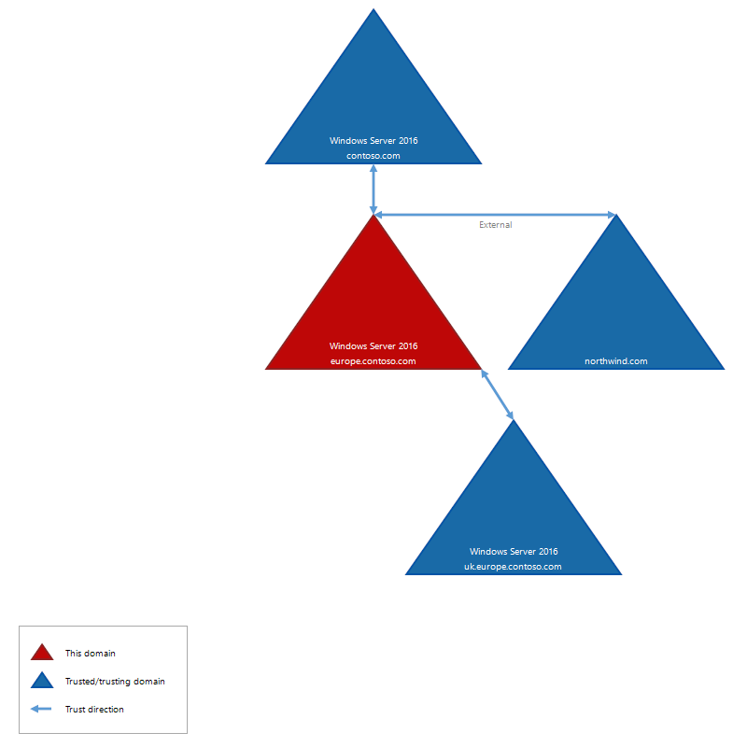

|  |  |  |  |  |
| --- | --- | --- | --- | --- |
| |  |  | | --- | --- | |  | 3 Trusts | | | |
| Target Domain Name | Type | Direction |
| |  |  | | --- | --- | |  | contoso.com | | Parent | Bidirectional |
| |  |  | | --- | --- | |  | northwind.com | | External | Bidirectional |
| |  |  | | --- | --- | |  | uk.europe.contoso.com | | Child | Bidirectional |

### contoso.com

Active Directory Domain Services (AD DS) provides security across multiple domains or forests through domain and forest trust relationships

|  |  |  |  |
| --- | --- | --- | --- |
| |  |  | | --- | --- | |  | General | | |
| Direction | Bidirectional |
| Trust Type | Parent |

|  |  |  |  |
| --- | --- | --- | --- |
| |  |  | | --- | --- | |  | Target Domain | | |
| Target Domain Name | contoso.com |
| Target Domain Functional Level | Windows Server 2016 |
| Target NetBIOS Name | CONTOSO |
| Target Security Identifier | S-1-5-21-3658165781-1802088474-919021730 |

|  |  |  |  |
| --- | --- | --- | --- |
| |  |  | | --- | --- | |  | Security | | |
| Enable Kerberos AES Encryption | False |
| Selective Authentication | False |
| SID History | False |
| SID Filtering Quarantined | False |
| TGT Delegation | False |

### northwind.com

Active Directory Domain Services (AD DS) provides security across multiple domains or forests through domain and forest trust relationships

|  |  |  |  |
| --- | --- | --- | --- |
| |  |  | | --- | --- | |  | General | | |
| Direction | Bidirectional |
| Trust Type | External |

|  |  |  |  |
| --- | --- | --- | --- |
| |  |  | | --- | --- | |  | Target Domain | | |
| Target Domain Name | northwind.com |
| Target NetBIOS Name | NORTHWIND |
| Target Security Identifier | S-1-5-21-2158724555-1125807419-3241227723 |

|  |  |  |  |
| --- | --- | --- | --- |
| |  |  | | --- | --- | |  | Security | | |
| Enable Kerberos AES Encryption | False |
| Selective Authentication | False |
| SID History | False |
| SID Filtering Quarantined | True |
| TGT Delegation | False |

### uk.europe.contoso.com

Active Directory Domain Services (AD DS) provides security across multiple domains or forests through domain and forest trust relationships

|  |  |  |  |
| --- | --- | --- | --- |
| |  |  | | --- | --- | |  | General | | |
| Direction | Bidirectional |
| Trust Type | Child |

|  |  |  |  |
| --- | --- | --- | --- |
| |  |  | | --- | --- | |  | Target Domain | | |
| Target Domain Name | uk.europe.contoso.com |
| Target Domain Functional Level | Windows Server 2016 |
| Target NetBIOS Name | UK |
| Target Security Identifier | S-1-5-21-3497076482-1246770663-2237968389 |

|  |  |  |  |
| --- | --- | --- | --- |
| |  |  | | --- | --- | |  | Security | | |
| Enable Kerberos AES Encryption | False |
| Selective Authentication | False |
| SID History | False |
| SID Filtering Quarantined | False |
| TGT Delegation | False |

## Users

Active Directory user accounts provide access to network resources. The accounts may represent a person, or act as dedicated service account for an application.

|  |  |  |  |  |
| --- | --- | --- | --- | --- |
| |  |  | | --- | --- | |  | 2 Users | | | |
| Name | Display Name | Description |
| |  |  | | --- | --- | |  | Administrator | | Administrator | Built-in account for administering the computer/domain |
| |  |  | | --- | --- | |  | Guest | | Guest | Built-in account for guest access to the computer/domain |

### Administrator

Active Directory user accounts provide access to network resources. The accounts may represent a person, or act as dedicated service account for an application.

|  |  |  |  |
| --- | --- | --- | --- |
| |  |  | | --- | --- | |  | General | | |
| First Name | Administrator |
| Last Name | Account |
| Display Name | Administrator |
| Description | Built-in account for administering the computer/domain |
| Enabled | True |
| Account Locked Out | False |
| Security Identifier | S-1-5-21-4140458633-4188990453-1364030867-500 |

|  |  |  |  |
| --- | --- | --- | --- |
| |  |  | | --- | --- | |  | Account Settings | | |
| User Principal Name |  |
| SAM Account Name | Administrator |
| Last Logon | 18 August 2023 17:06:50 |
| Account Expiration Date | [Not Configured] |
| Password Last Set | 18 August 2023 16:49:32 |
| Password Never Expires | True |
| User Cannot Change Password | False |
| User Must Change Password | False |

|  |  |  |  |
| --- | --- | --- | --- |
| |  |  | | --- | --- | |  | Profile | | |
| Home Directory | \\DC-CS-2K22\Home\Administrator |
| Home Drive | Z: |
| Profile Path | \\DC-CS-2K22\Profiles\Administrator |
| Script Path | Administrator.ps1 |

|  |  |  |  |  |
| --- | --- | --- | --- | --- |
| |  |  | | --- | --- | |  | 5 Memberships | | | |
| Account Name | Canonical Name | Type |
| |  |  | | --- | --- | |  | EUROPE\Domain Users | | europe.contoso.com/Users/Domain Users | Group |
| |  |  | | --- | --- | |  | CONTOSO\Enterprise Admins | | contoso.com/Users/Enterprise Admins | Group |
| |  |  | | --- | --- | |  | EUROPE\Group Policy Creator Owners | | europe.contoso.com/Users/Group Policy Creator Owners | Group |
| |  |  | | --- | --- | |  | EUROPE\Domain Admins | | europe.contoso.com/Users/Domain Admins | Group |
| |  |  | | --- | --- | |  | BUILTIN\Administrators | | europe.contoso.com/Builtin/Administrators | Group |

|  |  |  |
| --- | --- | --- |
| |  |  | | --- | --- | |  | Manager | |

|  |
| --- |
| No account is assigned. |

|  |  |  |  |
| --- | --- | --- | --- |
| |  |  | | --- | --- | |  | Directory Object | | |
| Date Created | 18 August 2023 16:58:54 |
| Date Last Modified | 25 August 2023 11:55:03 |
| Canonical Name | europe.contoso.com/Users/Administrator |
| Distinguished Name | CN=Administrator,CN=Users,DC=europe,DC=contoso,DC=com |
| Identifier | b281d6ff-1ede-437d-8ad8-8e2913433125 |
| Protected From Accidental Deletion | False |

### Guest

Active Directory user accounts provide access to network resources. The accounts may represent a person, or act as dedicated service account for an application.

|  |  |  |  |
| --- | --- | --- | --- |
| |  |  | | --- | --- | |  | General | | |
| First Name | Guest |
| Last Name | Account |
| Display Name | Guest |
| Description | Built-in account for guest access to the computer/domain |
| Enabled | False |
| Account Locked Out | False |
| Security Identifier | S-1-5-21-4140458633-4188990453-1364030867-501 |

|  |  |  |  |
| --- | --- | --- | --- |
| |  |  | | --- | --- | |  | Account Settings | | |
| User Principal Name |  |
| SAM Account Name | Guest |
| Last Logon | [Not Configured] |
| Account Expiration Date | [Not Configured] |
| Password Last Set | Never |
| Password Never Expires | True |
| User Cannot Change Password | False |
| User Must Change Password | False |

|  |  |  |  |
| --- | --- | --- | --- |
| |  |  | | --- | --- | |  | Profile | | |
| Home Directory | \\DC-CS-2K22\Home\Guest |
| Home Drive | Z: |
| Profile Path | \\DC-CS-2K22\Profiles\Guest |
| Script Path | Guest.ps1 |

|  |  |  |  |  |
| --- | --- | --- | --- | --- |
| |  |  | | --- | --- | |  | 2 Memberships | | | |
| Account Name | Canonical Name | Type |
| |  |  | | --- | --- | |  | EUROPE\Domain Guests | | europe.contoso.com/Users/Domain Guests | Group |
| |  |  | | --- | --- | |  | BUILTIN\Guests | | europe.contoso.com/Builtin/Guests | Group |

|  |  |  |  |  |
| --- | --- | --- | --- | --- |
| |  |  | | --- | --- | |  | Manager | | | |
| Account Name | Canonical Name | Type |
| |  |  | | --- | --- | |  | EUROPE\Administrator | | europe.contoso.com/Users/Administrator | User |

|  |  |  |  |
| --- | --- | --- | --- |
| |  |  | | --- | --- | |  | Directory Object | | |
| Date Created | 18 August 2023 16:58:54 |
| Date Last Modified | 18 August 2023 16:58:54 |
| Canonical Name | europe.contoso.com/Users/Guest |
| Distinguished Name | CN=Guest,CN=Users,DC=europe,DC=contoso,DC=com |
| Identifier | e38146c5-512f-44de-80c6-cc55d6382189 |
| Protected From Accidental Deletion | False |

# Group Policy

Group Policy is a Microsoft technology that provides centralized configuration and management of Windows based machines.

## Group Policy Objects

Group Policy objects provide a method of centralizing the configuration and management of Windows based machines.

|  |  |  |  |  |
| --- | --- | --- | --- | --- |
| |  |  | | --- | --- | |  | 1 Group Policy Objects | | | |
| Name | Status | WMI Filter |
| |  |  | | --- | --- | |  | Contoso Basic Group Policy Object | | Enabled |  |

### Contoso Basic Group Policy Object

Group Policy objects provide a method of centralizing the configuration and management of Windows based machines.

|  |  |  |  |
| --- | --- | --- | --- |
| |  |  | | --- | --- | |  | General | | |
| Description |  |
| GPO Status | Enabled |
| Date Created | 04 September 2025 14:40:58 |
| Date Last Modified | 04 September 2025 14:54:28 |
| Identifier | b131c36b-6258-4ca6-b1a0-b9c3957a453d |
| Owner | EUROPE\Domain Admins |

|  |  |  |  |
| --- | --- | --- | --- |
| |  |  | | --- | --- | |  | Computer | | |
| Computer Settings Enabled | True |
| Computer Version (Directory) | 9 |
| Computer Version (SYSVOL) | 9 |

|  |  |  |  |
| --- | --- | --- | --- |
| |  |  | | --- | --- | |  | User | | |
| User Settings Enabled | True |
| User Version (Directory) | 0 |
| User Version (SYSVOL) | 0 |

|  |  |  |
| --- | --- | --- |
| |  |  | | --- | --- | |  | 0 Links | |

|  |
| --- |
| There are no links found for the Group Policy object. |

|  |  |  |  |  |
| --- | --- | --- | --- | --- |
| |  |  | | --- | --- | |  | 5 Permissions | | | |
| Account Name | Permission Type | Rights |
| |  |  | | --- | --- | |  | CONTOSO\Enterprise Admins | | Allow | Edit Settings, Delete, Modify Security |
| |  |  | | --- | --- | |  | EUROPE\Domain Admins | | Allow | Edit Settings, Delete, Modify Security |
| |  |  | | --- | --- | |  | NT AUTHORITY\Authenticated Users | | Allow | Apply Group Policy |
| |  |  | | --- | --- | |  | NT AUTHORITY\ENTERPRISE DOMAIN CONTROLLERS | | Allow | Read |
| |  |  | | --- | --- | |  | NT AUTHORITY\SYSTEM | | Allow | Edit Settings, Delete, Modify Security |

|  |  |  |  |
| --- | --- | --- | --- |
| |  |  | | --- | --- | |  | WMI Filter | | |
| Assigned | False |

#### Computer Configuration

Provides information about the configured computer related Group Policy settings.

|  |  |  |  |
| --- | --- | --- | --- |
| |  |  | | --- | --- | |  | 1 Extensions | | |
| Name | State |
| |  |  | | --- | --- | |  | Administrative Templates | | Configured |

##### Administrative Templates

Provides information about the settings configured by the extension.

|  |  |  |  |
| --- | --- | --- | --- |
| |  |  | | --- | --- | |  | 5 Administrative Template Policies | | |
| Name | Value |
| |  |  | | --- | --- | |  | Control Panel/Personalization/Do not display the lock screen | | |
| |  |  | | --- | --- | |  | State | | Enabled |
| |  |  | | --- | --- | |  | Supported On | | At least Windows Server 2012, Windows 8 or Windows RT |
| |  |  | | --- | --- | |  | Network/Network Connections/Windows Defender Firewall/Domain Profile/Windows Defender Firewall: Allow logging | | |
| |  |  | | --- | --- | |  | State | | Enabled |
| |  |  | | --- | --- | |  | Supported On | | At least Windows XP Professional with SP2 |
| |  |  | | --- | --- | |  | Log dropped packets | | Enabled |
| |  |  | | --- | --- | |  | Log successful connections | | Disabled |
| |  |  | | --- | --- | |  | Log file path and name | | %systemroot%\system32\LogFiles\Firewall\pfirewall.log |
| |  |  | | --- | --- | |  | Size limit (KB) | | 4,096 |
| |  |  | | --- | --- | |  | Printers/Automatically publish new printers in Active Directory | | |
| |  |  | | --- | --- | |  | State | | Enabled |
| |  |  | | --- | --- | |  | Supported On | | Windows Server 2003, Windows XP, and Windows 2000 only |
| |  |  | | --- | --- | |  | System/Logon/Do not display the Getting Started welcome screen at logon | | |
| |  |  | | --- | --- | |  | State | | Enabled |
| |  |  | | --- | --- | |  | Supported On | | Windows 2000 only |
| |  |  | | --- | --- | |  | Windows Components/Internet Explorer/Disable Internet Explorer 11 as a standalone browser | | |
| |  |  | | --- | --- | |  | State | | Enabled |
| |  |  | | --- | --- | |  | Supported On | | At least Internet Explorer 11.0 on Windows 10 |
| |  |  | | --- | --- | |  | Notify that Internet Explorer 11 browser is disabled | | Once per user |

#### User Configuration

Provides information about the configured user related Group Policy settings.

|  |  |  |
| --- | --- | --- |
| |  |  | | --- | --- | |  | 0 Extensions | |

|  |
| --- |
| There are no extensions found for the configuration. |

## Starter Group Policy Objects

Starter Group Policy Objects are Group Policy templates that provide the ability to store a collection of Administrative Template policy settings in a single object which can easily be distributed and imported into other environments.

|  |  |  |
| --- | --- | --- |
| |  |  | | --- | --- | |  | 0 Starter Group Policy Objects | |

|  |
| --- |
| Information is not available for this section because the component or feature is not installed. |

# Replication

Active Directory replication is the process of transferring and updating Active Directory objects between domain controllers in the Active Directory domain and forest.

## Inter-Site Transports

Site links in Active Directory represent the inter-site connectivity and method used to transfer replication traffic.

|  |  |  |  |  |
| --- | --- | --- | --- | --- |
| |  |  | | --- | --- | |  | 2 Inter-Site Transports | | | |
| Name | Bridge All Site Links | Description |
| |  |  | | --- | --- | |  | IP | | True | Contains IP site links. |
| |  |  | | --- | --- | |  | SMTP | | True | Contains SMTP site links. |

### IP

Site links in Active Directory represent the inter-site connectivity and method used to transfer replication traffic.

|  |  |  |  |
| --- | --- | --- | --- |
| |  |  | | --- | --- | |  | General | | |
| Description | Contains IP site links. |
| Bridge All Site Links | True |
| Ignore Schedules | False |

|  |  |  |  |  |  |
| --- | --- | --- | --- | --- | --- |
| |  |  | | --- | --- | |  | 2 Site Links | | | | |
| Name | Cost | Transport Protocol | Description |
| |  |  | | --- | --- | |  | DEFAULTIPSITELINK | | 100 | IP | This is the default site link |
| |  |  | | --- | --- | |  | Remote Site Link | | 100 | IP | This is a remote site link. |

|  |  |  |  |  |
| --- | --- | --- | --- | --- |
| |  |  | | --- | --- | |  | 1 Site Link Bridges | | | |
| Name | Transport Protocol | Description |
| |  |  | | --- | --- | |  | Site Link Bridge | | IP | This is a site link bridge. |

### SMTP

Site links in Active Directory represent the inter-site connectivity and method used to transfer replication traffic.

|  |  |  |  |
| --- | --- | --- | --- |
| |  |  | | --- | --- | |  | General | | |
| Description | Contains SMTP site links. |
| Bridge All Site Links | True |
| Ignore Schedules | True |

|  |  |  |  |  |  |
| --- | --- | --- | --- | --- | --- |
| |  |  | | --- | --- | |  | 1 Site Links | | | | |
| Name | Cost | Transport Protocol | Description |
| |  |  | | --- | --- | |  | SMTP Site Link | | 100 | SMTP | This is an SMTP site link. |

|  |  |  |
| --- | --- | --- |
| |  |  | | --- | --- | |  | 0 Site Link Bridges | |

|  |
| --- |
| There are no site link bridges found for the inter-site transport. |

## Sites

Sites are Active Directory objects that represent one or more TCP/IP subnets with highly reliable and fast network connections.

|  |  |  |  |  |
| --- | --- | --- | --- | --- |
| |  |  | | --- | --- | |  | 1 Sites | | | |
| Name | Location | Description |
| |  |  | | --- | --- | |  | Contoso-Europe | | Europe | A site for Contoso Europe. |

### Contoso-Europe

Sites are Active Directory objects that represent one or more TCP/IP subnets with highly reliable and fast network connections.

|  |  |  |  |
| --- | --- | --- | --- |
| |  |  | | --- | --- | |  | General | | |
| Description | A site for Contoso Europe. |
| Location | Europe |
| Subnet Names | 157.54.208.0/20 |
| Schedule Hashing | False |

|  |  |  |
| --- | --- | --- |
| |  |  | | --- | --- | |  | Replication Schedule | |

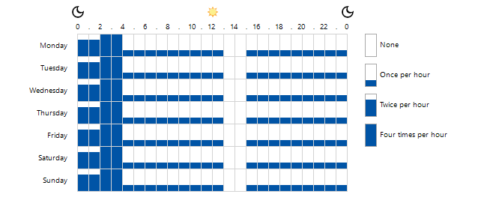

|  |  |  |  |
| --- | --- | --- | --- |
| |  |  | | --- | --- | |  | Universal Group Membership Caching | | |
| Universal Group Caching Enabled | False |

|  |  |  |  |
| --- | --- | --- | --- |
| |  |  | | --- | --- | |  | Inter-Site Topology Generator | | |
| Inter-Site Topology Generator | DC-EU-2K22 |
| Inter-Site Topology Generator Site | Contoso-Europe |
| Automatic Inter-Site Topology Generation | True |
| Automatic Topology Generation | True |

|  |  |  |  |
| --- | --- | --- | --- |
| |  |  | | --- | --- | |  | Topology | | |
| Redundant Server Topology | False |
| Topology Cleanup | True |
| Topology Detect Stale | True |
| Topology Minimum Hops | True |

|  |  |  |  |
| --- | --- | --- | --- |
| |  |  | | --- | --- | |  | Compatibility Settings | | |
| Windows Server 2000 Bridgehead Selection Method | True |
| Windows Server 2000 KCC ISTG Selection Behavior | False |
| Windows Server 2003 KCC Behavior Enabled | False |
| Windows Server 2003 KCC Ignore Schedule Enabled | False |
| Windows Server 2003 KCC Site Link Bridging Enabled | False |

|  |  |  |  |
| --- | --- | --- | --- |
| |  |  | | --- | --- | |  | Directory Object | | |
| Date Created | 25 August 2023 14:04:10 |
| Date Last Modified | 25 August 2023 15:13:07 |
| Canonical Name | contoso.com/Configuration/Sites/Contoso-Europe |
| Distinguished Name | CN=Contoso-Europe,CN=Sites,CN=Configuration,DC=contoso,DC=com |
| Identifier | d0aea32c-ff8a-470f-9997-d231b98dff36 |
| Protected From Accidental Deletion | False |

|  |  |  |  |
| --- | --- | --- | --- |
| |  |  | | --- | --- | |  | Security | | |
| Owner | S-1-5-21-3658165781-1802088474-919021730-519 |

|  |  |  |  |  |  |  |
| --- | --- | --- | --- | --- | --- | --- |
| |  |  | | --- | --- | |  | 3 Access Rules | | | | | |
| Account Name | Inherited | Action | Rights | Applies To |
| |  |  | | --- | --- | |  | NT AUTHORITY\Authenticated Users | | False | Allow | Read | This object only |
| |  |  | | --- | --- | |  | NT AUTHORITY\ENTERPRISE DOMAIN CONTROLLERS | | False | Allow | Read | This object only |
| |  |  | | --- | --- | |  | NT AUTHORITY\SYSTEM | | False | Allow | Full Control | This object only |

|  |  |  |  |  |  |  |
| --- | --- | --- | --- | --- | --- | --- |
| |  |  | | --- | --- | |  | 5 Audit Rules | | | | | |
| Account Name | Inherited | Type | Rights | Applies To |
| |  |  | | --- | --- | |  | Everyone | | True | Success | Create all child objects  Delete  Delete all child objects  Delete subtree | This object and all descendant objects |
| |  |  | | --- | --- | |  | Everyone | | True | Success | Extended right | Descendant 'NTDS-DSA' objects |
| |  |  | | --- | --- | |  | Everyone | | True | Success | WriteProperty: GP-Link | This object and all descendant objects |
| |  |  | | --- | --- | |  | Everyone | | True | Success | WriteProperty: GP-Options | This object and all descendant objects |
| |  |  | | --- | --- | |  | Everyone | | True | Success | WriteProperty: Site-Object | Descendant 'Subnet' objects |

#### Servers

A replication server is a domain controller that participates in hosting the Active Directory service.

|  |  |  |  |  |  |
| --- | --- | --- | --- | --- | --- |
| |  |  | | --- | --- | |  | 1 Replication Servers | | | | |
| Name | Read-Only | Global Catalog | Description |
| |  |  | | --- | --- | |  | DC-EU-2K22 | | False | True | The DC in europe. |

##### DC-EU-2K22

A replication server is a domain controller that participates in hosting the Active Directory service.

|  |  |  |  |
| --- | --- | --- | --- |
| |  |  | | --- | --- | |  | General | | |
| Bridgehead Server Transports |  |
| Description | The DC in europe. |
| Domain Name | europe.contoso.com |
| Host Name | DC-EU-2K22.europe.contoso.com |
| Global Catalog | True |
| Read Only | False |
| Location |  |
| Query Policy | Default Query Policy |

|  |  |  |  |  |
| --- | --- | --- | --- | --- |
| |  |  | | --- | --- | |  | 1 Replication Connections | | | |
| Name | Source Server | Source Site |
| |  |  | | --- | --- | |  | Automatically Generated | | DC-UK-2K22 | Default-First-Site-Name |

|  |  |  |  |
| --- | --- | --- | --- |
| |  |  | | --- | --- | |  | Directory Object | | |
| Date Created | 18 August 2023 16:58:50 |
| Date Last Modified | 25 August 2023 15:09:02 |
| Canonical Name | contoso.com/Configuration/Sites/Contoso-Europe/Servers/DC-EU-2K22 |
| Distinguished Name | CN=DC-EU-2K22,CN=Servers,CN=Contoso-Europe,CN=Sites,CN=Configuration,DC=contoso,DC=com |
| Identifier | e9d90425-7063-4caa-99ab-2a449e9959f8 |
| Protected From Accidental Deletion | False |

###### Automatically Generated

A replication connection determines the replication of Active Directory data from a source domain controller to a destination domain controller.

|  |  |  |  |
| --- | --- | --- | --- |
| |  |  | | --- | --- | |  | General | | |
| Auto Generated | True |
| Compression Enabled | True |
| Description |  |
| Identifier | 676b7dcc-8bb6-43f8-b7e7-93e11382a326 |
| Enabled | True |
| RODC Connection | False |
| Override Notify Default | False |
| Transport Protocol | IP |
| Use Notify | False |

|  |  |  |  |
| --- | --- | --- | --- |
| |  |  | | --- | --- | |  | Replication Source | | |
| Source Server Name | DC-UK-2K22 |
| Source Site Name | Default-First-Site-Name |
| Replicated Naming Contexts | CN=Configuration,DC=contoso,DC=com  CN=Schema,CN=Configuration,DC=contoso,DC=com  DC=europe,DC=contoso,DC=com |
| Partially Replicated Naming Contexts | DC=contoso,DC=com  DC=uk,DC=europe,DC=contoso,DC=com |

|  |  |  |
| --- | --- | --- |
| |  |  | | --- | --- | |  | Replication Schedule | |

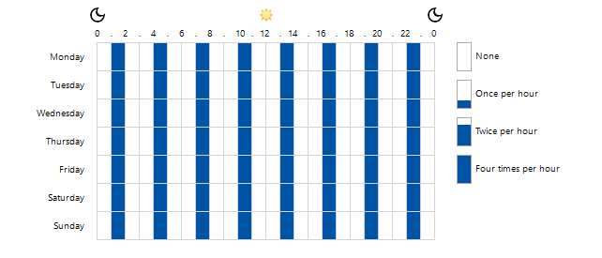

|  |  |  |  |
| --- | --- | --- | --- |
| |  |  | | --- | --- | |  | Directory Object | | |
| Date Created | 18 August 2023 17:33:24 |
| Date Last Modified | 25 August 2023 14:06:09 |
| Canonical Name | contoso.com/Configuration/Sites/Contoso-Europe/Servers/DC-EU-2K22/NTDS Settings/2ecf4425-9836-4a90-9241-74640cfd6e6c |
| Distinguished Name | CN=2ecf4425-9836-4a90-9241-74640cfd6e6c,CN=NTDS Settings,CN=DC-EU-2K22,CN=Servers,CN=Contoso-Europe,CN=Sites,CN=Configuration,DC=contoso,DC=com |
| Identifier | 676b7dcc-8bb6-43f8-b7e7-93e11382a326 |
| Protected From Accidental Deletion | False |

## Subnets

Subnets group computers in a way that identifies their physical proximity on the network. Subnet in Active Directory are used to map computers to sites.

|  |  |  |  |  |  |
| --- | --- | --- | --- | --- | --- |
| |  |  | | --- | --- | |  | 1 Subnets | | | | |
| Name | Site | Location | Description |
| |  |  | | --- | --- | |  | 157.54.208.0/20 | | Contoso-Europe | Europe | This is an example subnet. |

# Schema

The Microsoft Active Directory schema contains formal definitions of every object class that can be created in an Active Directory forest.

|  |  |  |  |
| --- | --- | --- | --- |
| |  |  | | --- | --- | |  | Schema | | |
| Distinguished Name | CN=Schema,CN=Configuration,DC=contoso,DC=com |
| Schema Version | 88 |

## Schema Classes

In Active Directory the schema classes define the types of objects that can be stored in the directory.

|  |
| --- |
| Schema base objects (classes that are marked as being from the base schema included with the operating system) are not shown. |

|  |  |  |  |  |
| --- | --- | --- | --- | --- |
| |  |  | | --- | --- | |  | 2 Schema Classes | | | |
| Name | Type | Active |
| |  |  | | --- | --- | |  | account | | Structural | True |
| |  |  | | --- | --- | |  | addressTemplate | | Structural | True |

### account

In Active Directory the schema classes define the types of objects that can be stored in the directory.

|  |  |  |  |
| --- | --- | --- | --- |
| |  |  | | --- | --- | |  | General | | |
| Name | account |
| Description | The account object class is used to define entries representing computer accounts. |
| Common Name | account |
| Date Created | 10 November 2017 19:25:45 |
| Date Last Modified | 18 August 2023 16:58:51 |
| X.500 OID | 0.9.2342.19200300.100.4.5 |
| Class Type | Structural |
| Category | account |
| Show When Browsing | False |
| Active | True |
| Schema Base Object | False |

|  |  |  |  |
| --- | --- | --- | --- |
| |  |  | | --- | --- | |  | Relationships | | |
| Parent | top |
| Auxiliary Classes |  |
| Possible Superiors | container  organizationalUnit |

|  |  |  |  |
| --- | --- | --- | --- |
| |  |  | | --- | --- | |  | Attributes | | |
| Required Attributes |  |
| Optional Attributes | description  host  l  o  ou  seeAlso  uid |

|  |  |  |  |
| --- | --- | --- | --- |
| |  |  | | --- | --- | |  | Security | | |
| Default Security Descriptor | D:(A;;RPWPCRCCDCLCLOLORCWOWDSDDTDTSW;;;DA)(A;;RPWPCRCCDCLCLORCWOWDSDDTSW;;;SY)(A;;RPLCLORC;;;AU) |

### addressTemplate

In Active Directory the schema classes define the types of objects that can be stored in the directory.

|  |  |  |  |
| --- | --- | --- | --- |
| |  |  | | --- | --- | |  | General | | |
| Name | addressTemplate |
| Description | Address-Template |
| Common Name | Address-Template |
| Date Created | 10 November 2017 19:25:45 |
| Date Last Modified | 18 August 2023 16:58:51 |
| X.500 OID | 1.2.840.113556.1.3.58 |
| Class Type | Structural |
| Category | addressTemplate |
| Show When Browsing | False |
| Active | True |
| Schema Base Object | False |

|  |  |  |  |
| --- | --- | --- | --- |
| |  |  | | --- | --- | |  | Relationships | | |
| Parent | displayTemplate |
| Auxiliary Classes |  |
| Possible Superiors | container |

|  |  |  |  |
| --- | --- | --- | --- |
| |  |  | | --- | --- | |  | Attributes | | |
| Required Attributes | displayName |
| Optional Attributes | addressSyntax  addressType  perMsgDialogDisplayTable  perRecipDialogDisplayTable  proxyGenerationEnabled |

|  |  |  |  |
| --- | --- | --- | --- |
| |  |  | | --- | --- | |  | Security | | |
| Default Security Descriptor | D:(A;;RPWPCRCCDCLCLORCWOWDSDDTSW;;;DA)(A;;RPWPCRCCDCLCLORCWOWDSDDTSW;;;SY)(A;;RPLCLORC;;;AU) |

## Schema Attributes

In Active Directory the schema attributes define the types of values that can be set for objects stored in the directory.

|  |
| --- |
| Schema base objects (attributes that are marked as being from the base schema included with the operating system) are not shown. |

|  |  |  |  |  |
| --- | --- | --- | --- | --- |
| |  |  | | --- | --- | |  | 2 Schema Attributes | | | |
| Name | Syntax | Active |
| |  |  | | --- | --- | |  | associatedDomain | | IA5 String | True |
| |  |  | | --- | --- | |  | associatedName | | Distinguished Name | True |

### associatedDomain

In Active Directory the schema attributes define the types of values that can be set for objects stored in the directory.

|  |  |  |  |
| --- | --- | --- | --- |
| |  |  | | --- | --- | |  | General | | |
| Common Name | associatedDomain |
| Description | The associatedDomain attribute type specifies a DNS domain which is associated with an object. |
| Ambiguous Name Resolution (ANR) | False |
| Copy Attribute On Object Duplication | False |
| Date Created | 10 November 2017 19:25:44 |
| Date Last Modified | 18 August 2023 16:58:51 |
| Active | True |
| Schema Base Object | False |
| X.500 OID | 0.9.2342.19200300.100.1.37 |
| Replicate To Global Catalog | False |

|  |  |  |  |
| --- | --- | --- | --- |
| |  |  | | --- | --- | |  | Syntax | | |
| Syntax | IA5 String |
| Minimum Value | 0 |
| Maximum Value | 256 |
| Single Valued | False |

|  |  |  |  |
| --- | --- | --- | --- |
| |  |  | | --- | --- | |  | Index Settings | | |
| Indexed | False |
| Index Containerized Searches | False |

### associatedName

In Active Directory the schema attributes define the types of values that can be set for objects stored in the directory.

|  |  |  |  |
| --- | --- | --- | --- |
| |  |  | | --- | --- | |  | General | | |
| Common Name | associatedName |
| Description | The associatedName attribute type specifies an entry in the organizational DIT associated with a DNS domain. |
| Ambiguous Name Resolution (ANR) | False |
| Copy Attribute On Object Duplication | False |
| Date Created | 10 November 2017 19:25:44 |
| Date Last Modified | 18 August 2023 16:58:51 |
| Active | True |
| Schema Base Object | False |
| X.500 OID | 0.9.2342.19200300.100.1.38 |
| Replicate To Global Catalog | False |

|  |  |  |  |
| --- | --- | --- | --- |
| |  |  | | --- | --- | |  | Syntax | | |
| Syntax | Distinguished Name |
| Minimum Value | 0 |
| Maximum Value | 0 |
| Single Valued | False |

|  |  |  |  |
| --- | --- | --- | --- |
| |  |  | | --- | --- | |  | Index Settings | | |
| Indexed | False |
| Index Containerized Searches | False |

# Version History

The version history displays the changes that have been made to the documentation of the item over time - either automatically when a change has been detected, or manually by users of the system.

|  |  |  |  |  |  |  |
| --- | --- | --- | --- | --- | --- | --- |
| |  |  | | --- | --- | |  | 5 versions | | | | | |
| Version | Username | Date | Time | Description |
| |  |  | | --- | --- | |  | 1.04 | | CONTOSO\sysadmin | 04 September 2025 | 15:23 | Added Custom Item Details |
| |  |  | | --- | --- | |  | 1.03 | | CONTOSO\sysadmin | 04 September 2025 | 15:23 | Added Primary Owner Contact |
| |  |  | | --- | --- | |  | 1.02 | | CONTOSO\sysadmin | 04 September 2025 | 15:21 | Added Primary Owner Name |
| |  |  | | --- | --- | |  | 1.01 | | CONTOSO\sysadmin | 04 September 2025 | 15:19 | Updated by XIA Configuration Client Data |
| |  |  | | --- | --- | |  | 1.00 | | CONTOSO\sysadmin | 04 September 2025 | 15:19 | Item created. |



XIA Configuration is an IT infrastructure audit and documentation tool that removes the burden of time-consuming, manual, auditing and documentation work by turning it into automated processes that takes just seconds.